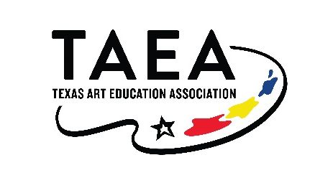
Dear (Administrator),
As you consider the importance of quality professional development for your staff members, please consider an opportunity important to me: the Texas Art Education Association Virtual Experience. This virtual conference offers a wonderful opportunity for art educators to gain valuable knowledge and expertise that can be shared with students.
Because of the Covid-19 pandemic, TAEA is offering a Virtual Experience for those teachers who were unable to attend the Fall 2021 Central Texas Conference in November.
Some of the activities include the following:
· Hundreds of quality artworks, Pre-K through college as well as museum studies
· Classes that show innovative techniques in the classroom
· Workshops provided will allow for CPE credit hours
· Vendors with up-to-date information on classroom supplies
· Educators willing to share information that benefit students
· Nationally recognized keynote speakers
· Workshops that integrate the TEKS and other core related subjects
· Strands specifically designed to meet the needs for the various grade levels

It is my goal to provide quality art education for the students in our school while also sharing and mentoring other art educators from across the state. I am asking for your support to attend this year’s virtual experience so that I might accomplish these goals.
You can visit www.taea.org for information on this virtual conference. Please consider this valuable opportunity and let me know if you can be of support with registration.
Sincerely,
(Teacher Name)

