Suggested Timeline for Teachers

August – October: encourage students to consider VASE while working on projects – go over basic guidelines (especially originality guidelines) including new ones.

December: Register for VASE on homepage www.taea.org/vase beginning on December 1. Find date and location for your event on the VASE website under Regional Directors and Dates on the homepage.

Mid-December:
- Give students information on the Regional Event.
- Start registering student artworks in VASE – continue all through December and into January.

Day of 1st Deadline: Add/Delete Deadline (30 days out). The number of entries at MIDNIGHT on this date must be accurate; this is the number of entries you will be responsible to pay for (you can edit the entries later, but the number of entries may not be changed after MIDNIGHT.

Day After 1st Deadline: Your invoice is ready to print. Print, then submit invoice to campus bookkeeper and request payment (students may pay, your principal may pay, or your campus budget/activity fund will pay). Your district arts administrator (if you have one) may pay for these fees; if this is the case, submit invoice to the administrator; he/she will send payment. Payments are due by 2nd deadline date to the TAEA Dallas office.

Day After 1st Deadline: Editing of VASE entries can begin. Make sure all artwork meets VASE guidelines, start preparing it for the event. Make sure all entry info is entered correctly, especially student division.

Late January/early February After 1st deadline: Give students practice Student Intent and Artwork Identification Forms if desired; you may guide students through the writing portion, but do NOT write it yourself. You may write what the student tells you, but you can’t do it for them. The teacher may begin working on Student Intent and Artwork Identification forms now.

Late January/early February (before 2nd Deadline): Check student eligibility and encourage students to keep grades up – all grades must be passing for students to participate. If a student becomes ineligible before the 2nd deadline (Editing Deadline), substitute another student and their artwork in its place.

3 Weeks Prior to Event: Check all entries for complete accuracy as the 2nd Deadline approaches (you can never check too many times). Entries may not be edited after the 2nd deadline. You may substitute one student for another student, change anything within the entries; you may not change the number of entries.

Day of 2nd Deadline: Editing Deadline. You may edit each entry until midnight – MUST have accurate dimension (2D/3D), must have unique, creative titles, and must have correct spelling of the students name.

Day after Deadline: Print menu is available – print and sign needed paper forms:
- Regional Entry Certification Form: must be printed & signed by you and your principal…principal is certifying that all the artwork meets community standards and all students are eligible. This form will be uploaded.
- Student Intent and Artwork ID Form: This form is filled out ONLINE. You will CERTIFY each entry on your Teacher Dashboard once you have verified that all parts of the entry are finished correctly; this substitutes for your signature.
- Student Agreement and Artwork Release Form: This form is printed, signed by student & parent if student is under 18, and you. You MUST collect these forms, scan or photograph them, then upload them into the student’s entry using your Teacher Dashboard.
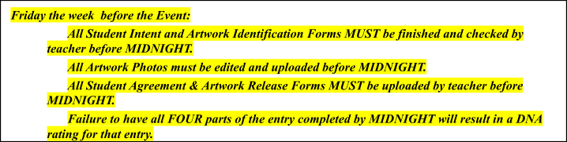

After Regional Event:
- Print Juror Rating Forms once your Regional Director has released them (usually in the evening after the event).
- Brag how wonderful your students did on social media, or write a press release for your Communications person. You and your students deserve recognition for your hard work and success.

